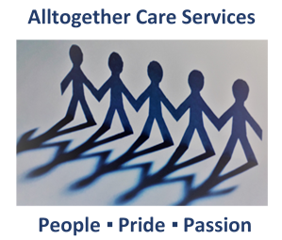
New Service User Enquiry
Alltogether Care Services pride themselves on the standard and quality
of care they give to Service Users and their families. This form will give
us a clearer picture of your requirements and enable us to give you the
information needed to make an informed decision about our Home Care
Services.

Enquiry From: |  | Representative |  | Service User:
Relationship: |  | Contact Number:
E-Mail:

Enquiry Date: |  | Taken By:
Where did you hear about us?

SERVICE USER DETAILS
Name:
Address:
Contact Number(s):
E-Mail:
Preferred Contact:
Service Type: | Private |  | Local Authority |  | Other

TYPE OF SERVICE(S) REQUIRED
Dementia Care |  | End of Life Care
Housework |  | Personal Care
Respite in the Home |  | Short Break
Socialisation |  | Other - please state
Number of Carers: |  | Current Care Provider:

Hours Required: |  |  |  |  | Frequency:
Days: | Mon |  | Tue |  | Wed |  | Thu |  | Fri |  | Sat |  | Sun

OFFICE USE ONLY | Senior Worker(s): |  |  | Margaret Dass/Rachael Dow
Meeting Arranged | Date: |  |  | Time:
Outcome: | Accepted |  | On Hold |  | Cancelled
Cancelled Reason:
Proposed Start Date:

NOTES

